

**Year 12 Integrated Science 2020**

**Task 1: Extended Response - Wetlands in Western Australia**

**Background Information**

Wetlands are vital for human survival. They are among the world’s most productive environments; cradles of biological diversity that provide the water and productivity upon which countless species of plants and animals depend for survival.

Wetlands are indispensable for the countless benefits or “ecosystem services” that they provide humanity, ranging from freshwater supply, food and building materials, and biodiversity, to flood control, groundwater recharge, and climate change mitigation.

Yet study after study demonstrates that wetland area and quality continue to decline in most regions of the world. As a result, the ecosystem services that wetlands provide to people are compromised.

Western Australia’s unique and diverse wetlands are rich in ecological and cultural values and form an integral part of the natural environment of the state.

**Task**

You are tasked with completing a research assignment on a significant wetland from Western Australia. The assignment involves:

* a set of research notes (see below for specifics)
* A 5 min presentation (powerpoint, video, poster, other) that outlines the key information from your research.

You need to choose one of the following wetlands (no more than 2 students can do each wetland).

* Vasse-Wonnerup System

**Key Dates**

Research Notes: Mon 10th – Thurs 13th Feb (3 lessons)

In-class presentation: Thurs 20th Feb 2020

**Task Weighting**

15% of the year mark.

**Total marks available**

60 marks

**Part 1: Research Notes [39 marks]**

You are required to research the answers for the following questions.

Your notes need to be:

* Written in your own words. ANY SECTIONS THAT ARE PLAGIARISED WILL NOT BE MARKED.
* Concise, using dot points where applicable.
* Correctly referenced (in-text and bibliography).

Your research notes **WILL** need to be submitted to your teacher at the beginning of the lesson of the final presentation.

**Useful resources**

<https://www.dpaw.wa.gov.au/management/wetlands>

<https://www.environment.gov.au/water/wetlands/ramsar/criteria-identifying-wetlands>

<https://www.environment.gov.au/water/wetlands/australian-wetlands-database/australian-ramsar-wetlands>

**Part 2: Presentation [21 marks]**

With the information you have collected through your research, produce a 5-minute presentation that will engage the viewer (your fellow peers). Your presentation must include all key information from your research. You can choose any presentation type you think applicable to present this information.

|  |  |  |  |
| --- | --- | --- | --- |
| **Description** | **3 marks** | **2 marks** | **1 mark** |
| Presentation of content   * PowerPoint * Video * Online website * Poster | 8-10 slides/sections included with key ideas linked to images and sources of information referenced. | 8-10 slides/sections included that shows organisation of ideas in each of the researched content areas. | **7 slides/sections included that is mainly text.** |
| Content | **Shows a full understanding of the topic** | Shows a good understanding of the topic | Shows some understanding of the topic |
| Use of headings and sub-headings | All headings and subheadings used. | **Some headings and subheadings used.** | Some headings used |
| Delivery | Speaks with fluctuation in volume and inflection to emphasize key points. | **Speaks with satisfactory variation of volume and inflection.** | Speaks in uneven volume with little or no inflection. |
| Creativity | Creative use of fonts, transitions or animation function that includes a short-embedded clip/s that have been produced by the student | Some attempt to use transitions or animation functions on PowerPoint. | **Some relevant images used and an attempt made to use colour, smart art or different fonts.** |
| Audience interest | Engaging and interesting all the way through. | **Captured interest reasonably well.** | Relevant information is included. |
| Engagement | High level of effort. | **Satisfactory level of effort.** | Little effort shown. |
| **Total** | **13/21** | | |

**Marking Guide**

|  |  |  |
| --- | --- | --- |
|  | **Item Description** | **Marks** |
| Research Notes | 1. *Wetland description*   Clearly define what constitutes a wetland  Outline the different types of wetlands and what makes them important. | **1**/2 |
| 1. *Ramsar Convention*   Correctly define what the Ramsar Convention is and clarify why is it important? | **1**/2 |
| 1. *Justification*   Identify which Ramsar Criteria your WA wetland qualifies for.  Clearly explain using multiple points how your WA wetlands meets this Ramsar Criteria. | **2**/4 |
| 1. *Map*   Provide a map of your WA wetland site (include geographical coordinates and location of nearest town or major town/city).  Ensure that you clearly delineate the various types of wetlands within your site. | **2**/4 |
| 1. *Key Features*   Analyse and describe the key features of your WA wetland site (biogeography, physical conditions, hydrological values, wetland type). | **4**/8 |
| 1. *Fishbone*   Use the Fishbone Template to classify noteworthy biotic factors (flora and fauna) that inhabit your WA wetland.  For each, describe what makes each one noteworthy. | **0**/6 |
| 1. *Social/Cultural Values*   Describe if the site has any social and/ or cultural values and detail what makes them important. | **1**/4 |
| 1. *Ecological Condition of your WA wetland*   Analyse how current land and water use activities within the Ramsar site and surrounding catchment are affecting the ecological character of your WA wetland. | **1**/6 |
| 1. *Referencing*   Include in-text referencing and provide a bibliography. | **2**/3 |
| **Research Notes Sub Total** | | **14/39** |
| Presentation | Presentation of content | **1**/3 |
| Content in presentation | **3**/3 |
| Use of headings | **2**/3 |
| Delivery | **2**/3 |
| Creativity | **1**/3 |
| Audience interest | **2**/3 |
| Engagement | **2**/3 |
| **Presentation Sub Total** | | **13/21** |
| **TOTAL** | | **27/60** |

**Part 1: Research Notes**

1. Wetland description (Define what constitutes a wetland and describe the different types of wetlands and what makes them important). **1 mark** (2 marks)

Australia has over 8.3 million hectares of wetlands with about 66 Ramsar wetlands. A wetland is a certain part of land that contains water either seasonally or intermittently. Even when Australia is the driest inhabited continent, it is home to a large amount of important wetlands and homes to birds that migrate across the world, wetlands are also important as they are home to fish, frogs and tortoises

1. Describe what the Ramsar Convention is and clarify why it is important. **1 mark** (2 marks)

The Ramsar convention is an intergovernmental treaty to protect and conserve wetlands across the world and to use their recourses wisely, along with protecting the homes of animals that live in certain wetlands.

1. Identify which Ramsar Criteria your WA wetland qualifies for. **0 marks** (1 mark)

Clearly explain using multiple points how your WA wetlands meets this Ramsar Criteria.

**2 marks which Ramsar numbers does it classify?** (3 marks)

My wetland is the Vasse-Wonnerup System, which is protected as it meets 2 of the Ramsar Criteria-

* “More than 33,000 waterbirds have been counted at the Vasse-Wonnerup System. Waterbird data indicate that more than 20,000 waterbirds use the Ramsar site each year, suggesting that the wetland regularly supports 20,000 waterfowl. This includes species such as Red-necked Avocets and Black-winged Stilts, Wood Sandpiper, Sharp-tailed Sandpiper, Long-toed Stint, Curlew Sandpiper and Common Greenshank.” -Referenced website

**What is the website?**

* “At least 1% of the Australian population of Black-winged Stilt and at least 1% of the world population of Red-necked Avocet use Vasse-Wonnerup System in most years.” -Referenced website

**What is the website?**

1. Provide a map of your WA wetland site (include geographical coordinates and location of nearest town or major town/city). Ensure that you clearly delineate the various types of wetlands within your site.

**Major town? Coordinates? 2 marks.** (4 marks)

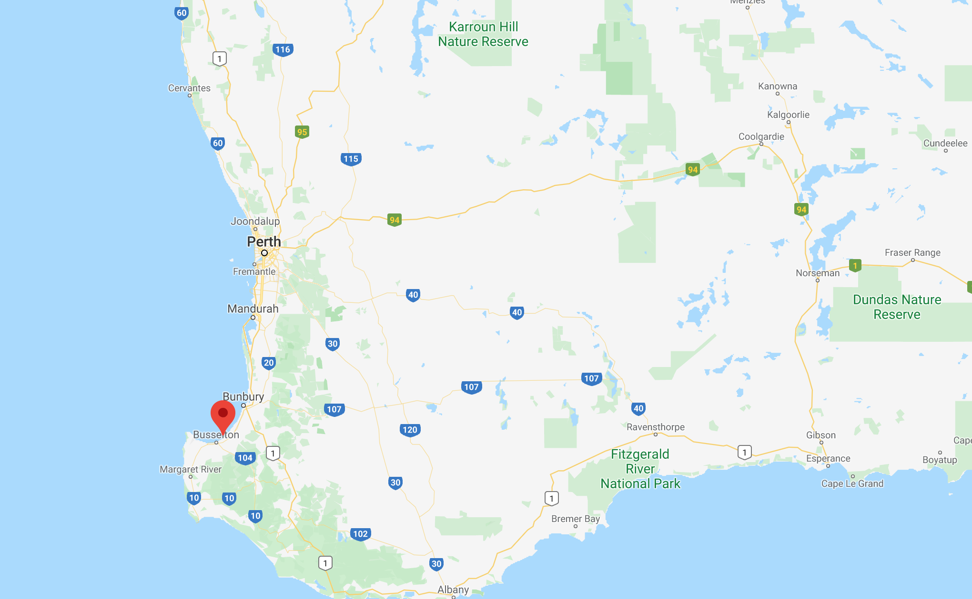

1. Analyse and describe the key features of your WA wetland site, include the following: biogeography, physical conditions (including climate data), hydrological values, wetland type. (8 marks)

* Physical conditions/Biogeography- The wetland is in the south-west coast and is 1115 hectares located on a narrow flat plain and is separated from the ocean by sand dunes, during the summer large areas of the wetlands dry out
* The wetland type- (Data taken straight from website)
* **J** - Coastal brackish/saline lagoons; brackish to saline lagoons with at least one relatively narrow connection to the sea
* **N** - Seasonal/intermittent/irregular rivers/streams/creeks
* **Ss** - Seasonal/intermittent saline/brackish/alkaline marshes/pools
* **Xf** - Freshwater, tree-dominated wetlands; includes freshwater swamp forests, seasonally flooded forests, wooded swamps on inorganic soils
* Hydrological values- The water management is focused on the revitalising geography waterways along with other leading waterways

**4 marks**

**You need to explain these points in your own words rather than just re-state them from the information document. Also what is the climate like here? The average annual temperature and rainfall?**

1. Use the Fishbone Template to classify noteworthy biotic factors (flora and fauna) that inhabit your WA wetland. For each, describe what makes each one noteworthy. **0 marks** (6 marks)
2. Describe if the site has any social and/ or cultural values and detail what makes them important.

* “The Sabina and Abba Rivers of the Ramsar site are important indigenous cultural heritage sites and the Ramsar site would have traditionally been used by indigenous people of the area. Other items of heritage value include the 1927 floodgates on the Vasse and Wonnerup Estuaries outlet channels.” -Referenced website **???? -How was it used by them?**
* “The native Water Rat has been recorded in the Vasse-Wonnerup System at several locations”

(4 marks)

**1 mark**

1. Analyse how current land and water use activities within your site and the surrounding catchment are affecting the ecological character of your WA wetland. (6 marks)

* Since the extension of the Vasse Wonnerup system, water levels have decreased and water quality has been majorly effected, making the site extremely dry during the summer

**HOW?**

**1 mark.**

1. Bibliography (Referencing) (3 marks)

<https://www.environment.gov.au/cgi-bin/wetlands/ramsardetails.pl?refcode=38>

<https://www.ramsar.org/about-the-convention-on-wetlands-0>

<https://www.environment.gov.au/water/wetlands/ramsar/criteria-identifying-wetlands>

<https://www.dpaw.wa.gov.au/management/wetlands>

<https://rgw.dwer.wa.gov.au/waterways-management/>

**In-text references aren’t always included and the actual reference used was not stated. 2 marks.**

